**Crime Vision: Advanced Crime Classification with Deep Learning**

**NAAN MUDHALVAN PROJECT REPORT**

**Submitted by**

**TEAM LEADER : GURUCHITHRA.SS**

**TEAM MEMBER 1: VENNILA K**

**TEAM MEMBER 2: NISHA S**

**TEAM MEMBER 3: MAHARAJA K**

**S.VEERASAMY CHETTIAR COLLEGE OF ENGINEERING ANDTECHNOLOGY,PULIANGUDI**

**ANNA UNIVERSITY: CHENNAI 600 025**

**MAY 2023**

1. **INTRODUCTION**

1.1 Project Overview

1.2 Purpose

2. **IDEATION & PROPOSED SOLUTION**

2.1 Problem Statement Definition

2.2 Empathy Map Canvas

2.3 Ideation & Brainstorming

2.4 Proposed Solution

3. **REQUIREMENT ANALYSIS**

3.1 Functional requirement

3.2 Non-Functional requirements

**4. PROJECT DESIGN**

4.1 Data Flow Diagrams

4.2 Solution & Technical Architecture

4.3 User Stories

**5. CODING & SOLUTIONING (Explain the features added in the project along with code)**

5.1 Feature 1

5.2 Feature 2

5.3 Database Schema (if Applicable)

**6. RESULTS**

6.1 Performance Metrics

**7. ADVANTAGES & DISADVANTAGES**

**8. CONCLUSION**

**9. FUTURE SCOPE**

**10. APPENDIX**

Source Code

GitHub & Project Video Demo Link

1.**INTRODUCTION**

1.1 Project Overview

Our objective is to study the prediction research work on crimes using AI. The objective is achieved through answering four main research questions. They covered the type and category of the crimes considered. The main ML algorithms that are used to predict crimes in relation to how accurate they are and determining what makes a certain training model suitable with the data provided. In addition to the strengths and limitations of the algorithms.

As a result, police departments spend a great deal of time and resources detecting crime trends and predicting them. With the growing shift toward technology and advancements in artificial intelligence (AI), Machine Learning (ML) techniques could reduce this effort by quickly analyzing large amounts of data to extract crime patterns (Feng et al., 2018). Several AI techniques have been widely studied to reduce or prevent crime and ensure the safety of people in different countries. Going forward, these machine learning models can be used in predicting future crimes, their attributes, etc.

By contrast, AI techniques could be useful in analyzing the datasets collected by police departments to extract patterns and predict future events. As an example, (Kim et al., 2019a), used such a dataset to examine crime data from Vancouver over the last 15 years. They used a heatmap to predict the areas most likely to experience crime, i.e., hotspots, and used different AI approaches, including boosted decision trees with K-nearest neighbors.

We present a systematic review study on AI strategies for crime prediction, which differs from existing work in this literature. Table 1 presents a small summary of other surveys and the difference between their contributions and ours. Our research differs from previous research in a number of ways, including the following:

1. Presents the main focus of research in crime prediction with respect to the type and category of the crime, the study time, and which type of crime has been addressed by the most researchers.

2. Clarifies the frequency of what algorithms were used in training models and what factors were considered when choosing them.

3. Analyzes the estimation accuracy of the models by focusing on four factors: performance metric, evaluation value, the dataset utilized, and the validation approaches for the model.

4. Demonstrates the tools applied in the selected research papers, the strengths and weaknesses of the prediction models, and the limitations and future direction of crime prediction.

5. Covers the period from 2008 to 2021, which addresses recent work.

1.2 Purpose

It aims to present the main focus of research in crime prediction with respect to the type and category of crime, the study time, and which type of crime has been addressed by the most researchers.

by performing spatial clustering, spatial correlation, studying hotspots, or even analyzing the demographics of census regions. Another approach to analysis is studying human behavior. This includes studying the criminal behavior, facial expression analysis, point of interest (POI) analysis, and analyzing activities.

Crime Vision uses a combination of computer vision, natural language processing, and machine learning techniques to analyze data from a variety of sources, including surveillance footage, social media posts, police reports, and other public records. The system is capable of identifying specific individuals, vehicles, and other objects of interest, as well as detecting patterns in criminal behavior over time.

Safety and security are key important aspects that improve the quality of life in urban areas. The authors (Zhao & Tang, 2018) presented an overview that summarized crime analysis in urban data, studied several types of criminal task algorithms, and discussed theories on criminology. Additionally, (Shamsuddin et al., 2017), provided a short, straightforward survey on the implementation of methods for crime prediction and the chances of improving them in the future. They used SVM, fuzzy theory, artificial neural networks, and multivariate time series as ML methods. On the other hand, (Fredrick David KR et al., 2017), presented a review of the supervised and unsupervised strategies for crime detection in which they analyzed and forecasted crimes.

2. **IDEATION & PROPOSED SOLUTION**

2.1 Problem Statement Definition

|  |  |
| --- | --- |
| Date | 29 April 2023 |
| Team ID | NM2023TMID12043 |
| Project Name | CrimeVision: Advanced Crime Classification with Deep Learning |
| Maximum Marks | 2 Marks |

**Customer Problem Statement Template:**

Create a problem statement to understand your customer's point of view. The Customer Problem Statement template helps you focus on what matters to create experiences people will love.

A well-articulated customer problem statement allows you and your team to find the ideal solution for the challenges your customers face. Throughout the process, you’ll also be able to empathize with your customers, which helps you better understand how they perceive your product or service.

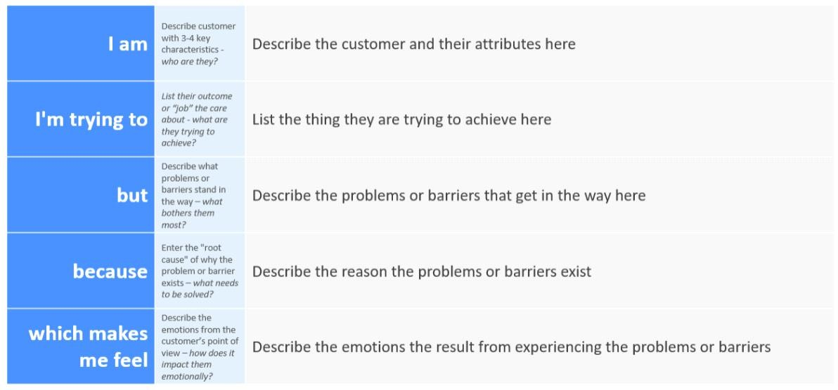

|  |  |  |  |  |  |
| --- | --- | --- | --- | --- | --- |
| **Problem** | **I am** | **I’m trying to** | **But** | **Because** | **Which makes me feel** |
| **Statement (PS)** | **(Customer)** |  |  |  |  |
| PS-1 | crime investigator | analyze and classify criminal | It takes long time | CrimeVision addresses this problem by using deep learning algorithms to analyze large amounts of data from various sources, such as crime reports, witness statements, and surveillance footage. | Frustration |

2.2 **Empathize & Discover**

|  |  |
| --- | --- |
| Date | 29 April 2023 |
| Team ID | NM2023TMID12043 |
| Project Name | Crime Vision: Advanced Crime Classification with Deep Learning |
| Maximum Marks | 4 Marks |

**Empathy Map Canvas:**

An empathy map is a simple, easy-to-digest visual that captures knowledge about a user’s behaviours and attitudes.

It is a useful tool to helps teams better understand their users.

Creating an effective solution requires understanding the true problem and the person who is experiencing it. The exercise of creating the map helps participants consider things from the user’s perspective along with his or her goals and challenges.

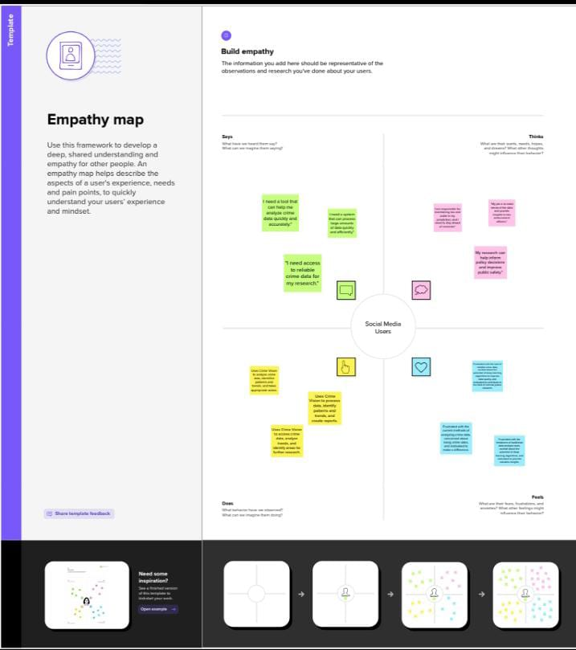

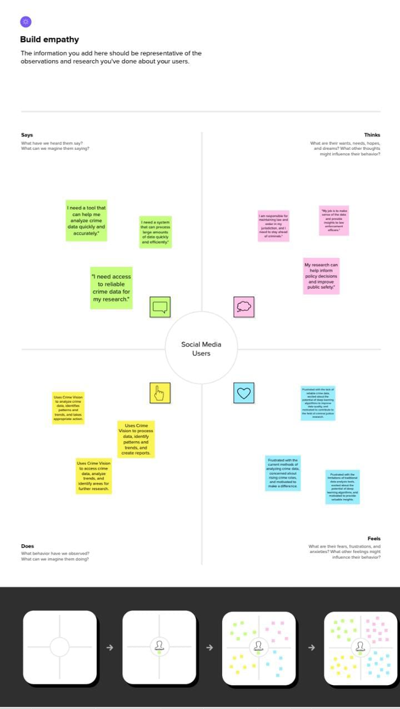

2.3 Ideation & Brainstorming

|  |  |
| --- | --- |
| Date | 29 April 2023 |
| Team ID | NM2023TMID12043 |
| Project Name | CrimeVision: Advanced Crime Classification with Deep Learning |
| Maximum Marks | 4 Marks |

**Brainstorm & Idea Prioritization Template:**

Brainstorming provides a free and open environment that encourages everyone within a team to participate in the creative thinking process that leads to problem solving. Prioritizing volume over value, out-of-the-box ideas are welcome and built upon, and all participants are encouraged to collaborate, helping each other develop a rich amount of creative solutions.

Use this template in your own brainstorming sessions so your team can unleash their imagination and start shaping concepts even if you're not sitting in the same room.

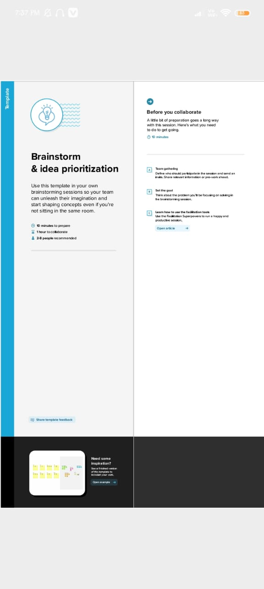

**The Problem Statement**

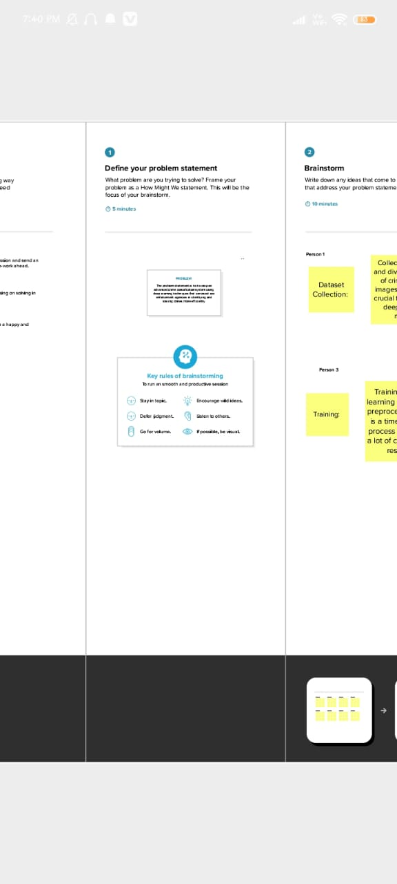

**Step-2: Brainstorm, Idea Listing and Grouping**

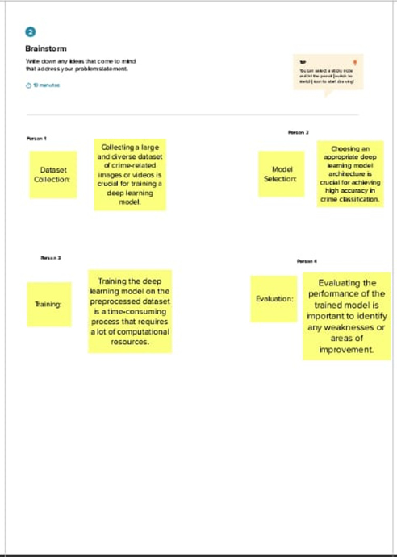

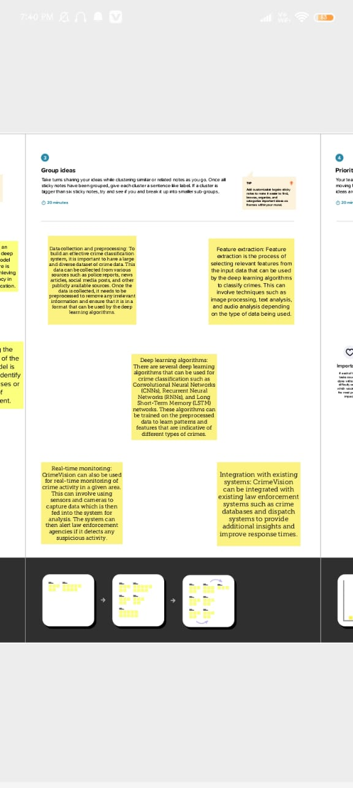

**Step-3: Idea Prioritization**

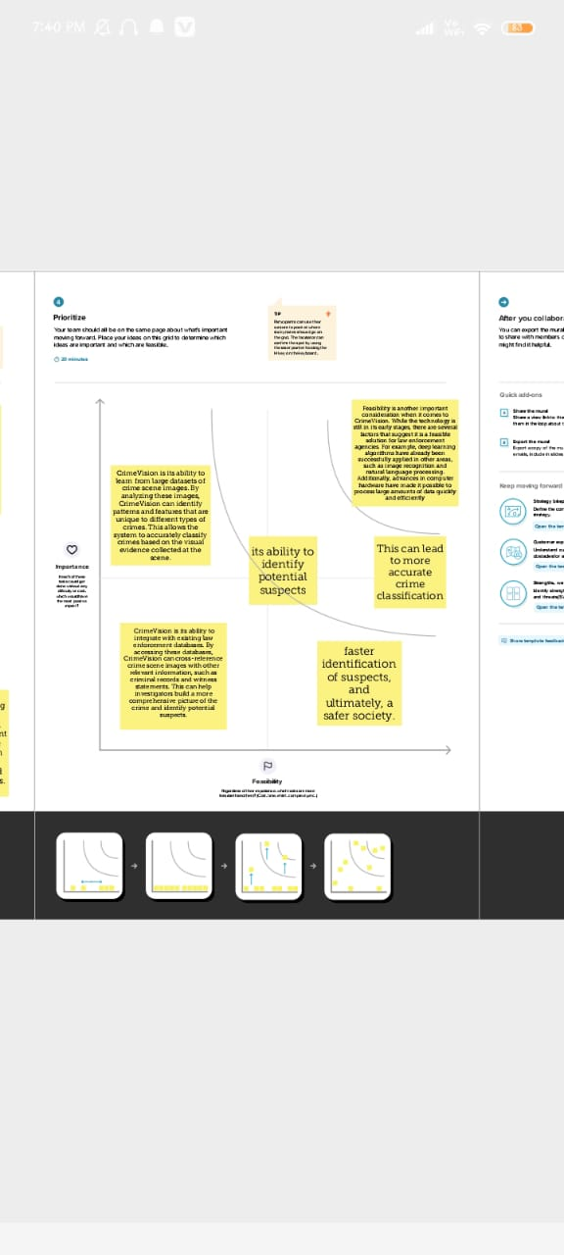

2.4 Proposed Solution

|  |  |
| --- | --- |
| Date | 06 May 2023 |
| Team ID | NM2023TMID12043 |
| Project Name | CrimeVision: Advanced Crime Classification with Deep Learning |
| Maximum Marks | 2 Marks |

**Proposed Solution Template:**

|  |  |  |
| --- | --- | --- |
| **S.No.** | **Parameter** | **Description** |
| • | Problem Statement (Problem to be solved) | CrimeVision is an advanced crime classification system that uses deep learning technology to analyze and classify criminal activities. The problem it aims to solve is the difficulty in accurately identifying and classifying crimes, which can lead to delays in investigations,  wrongful accusations, and inadequate allocation of resources. |
| • | Idea / Solution description | The solution involves using deep learning algorithms to analyze various data sources, including surveillance footage, crime reports, and social media activity. The system can identify patterns and correlations between different types of criminal activity and provide  accurate classifications. |
| • | Novelty / Uniqueness | The novelty of CrimeVision lies in its use of deep learning technology to provide a more accurate and efficient crime classification system. Unlike traditional methods that rely on human interpretation, CrimeVision can process  vast amounts of data quickly and accurately. |
| • | Social Impact / Customer Satisfaction | The social impact of CrimeVision is significant as it can help law enforcement agencies allocate resources more effectively, leading to faster investigations and reduced crime rates.  Additionally, the system can help prevent wrongful accusations by providing more accurate classifications of criminal activity. |
| • | Business Model (Revenue Model) | The business model for CrimeVision involves selling the system to law enforcement agencies and other organizations that require advanced  crime classification capabilities. Revenue is |

|  |  |  |
| --- | --- | --- |
|  |  | generated through licensing fees and ongoing support services. |
| • | Scalability of the Solution | The scalability of the solution is high as it can be adapted to different types of criminal activity and can be integrated with existing surveillance systems. Additionally, as more data is fed into the system, it becomes even more accurate at identifying patterns and correlations between criminal activities. |

3. **REQUIREMENT ANALYSIS**

* 1. Functional requirement

1.Data Collection and Integration: CrimeVision must be able to collect and integrate data from various sources, including law enforcement agencies, social media platforms, news outlets, and other relevant sources. The system must be able to extract relevant information from these sources and store it in a structured format.  
  
2. Crime Classification: CrimeVision must use deep learning algorithms to classify different types of crimes based on the available data. The system must be able to identify patterns and trends in the data to accurately classify crimes.  
  
3. Real-time Monitoring: CrimeVision must be able to monitor crime activity in real-time and provide alerts when a crime is detected. The system must be able to analyze large volumes of data quickly and accurately to provide timely alerts.  
  
4. Predictive Analytics: CrimeVision must use predictive analytics to identify potential crime hotspots and predict future crime trends. The system must be able to analyze historical data and identify patterns that can help predict future crime activity.  
  
5. User Interface: CrimeVision must have a user-friendly interface that allows users to easily access and analyze crime data. The system must provide visualizations, dashboards, and reports that enable users to quickly understand crime trends and patterns.  
  
6. Security: CrimeVision must have robust security measures in place to protect sensitive data from unauthorized access or theft. The system must comply with relevant data protection laws and regulations.  
  
7. Scalability: CrimeVision must be scalable to handle large volumes of data as the system grows. The system must be able to handle increasing amounts of data without compromising performance or accuracy.

* 1. Non-Functional requirements

1. **Reliability**: CrimeVision must be reliable in order to be effective. This means that the system must be able to accurately classify crime scenes and identify potential suspects with a high degree of accuracy. To achieve this, the system should be thoroughly tested and validated using real-world data sets.  
  
2. **Scalability**: CrimeVision must be able to scale to handle large volumes of data. This includes both the number of crime scenes that need to be processed as well as the amount of data associated with each scene. To achieve this, the system should be designed with scalability in mind, using distributed computing and other techniques as necessary.  
  
3. **Security**: CrimeVision must be secure in order to protect sensitive data and prevent unauthorized access. This includes both physical security measures (e.g., access controls) as well as digital security measures (e.g., encryption). The system should also be designed with auditing and logging capabilities to track access and usage.  
  
4. **Usability**: CrimeVision must be easy to use in order to be adopted by law enforcement agencies. This includes both the user interface as well as documentation and training materials. The system should also be designed with accessibility in mind, taking into account users with disabilities or other special needs.  
  
5. **Performance**: CrimeVision must perform quickly and efficiently in order to provide timely results to law enforcement agencies. This includes both processing speed as well as response time for queries and other interactions with the system.  
  
6. **Maintainability**: CrimeVision must be maintainable over time in order to remain effective. This includes both software updates as well as hardware maintenance and upgrades. The system should be designed with modularity in mind, allowing for easy updates and maintenance.

**4. PROJECT DESIGN**

4.1 Data Flow Diagrams

|  |  |
| --- | --- |
| Date | 13 May 2023 |
| Team ID | NM2023TMID12043 |
| Project Name | CrimeVision: Advanced Crime Classification with Deep Learning |
| Maximum Marks | 4 Marks |

A Data Flow Diagram (DFD) is a traditional visual representation of the information flows within a system. A neat and clear DFD can depict the right amount of the system requirement graphically. It shows how data enters and leaves the system, what changes the information, and where data is store.

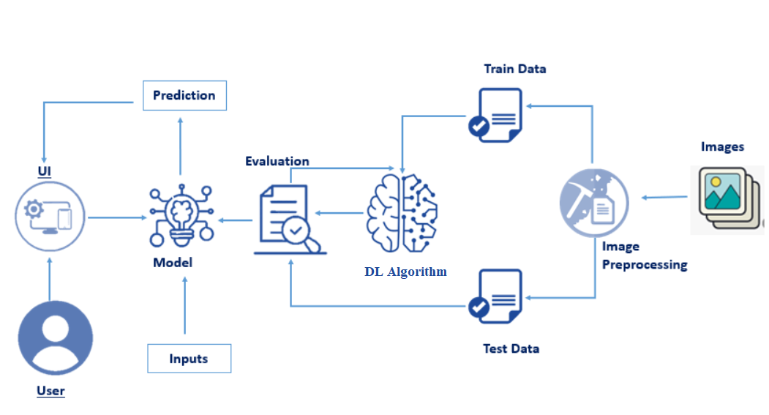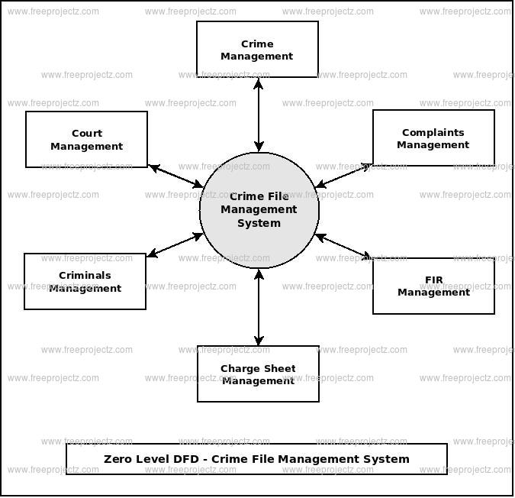

**4.3 User Stories**

|  |  |  |  |  |  |  |
| --- | --- | --- | --- | --- | --- | --- |
| **User Type** | **Functional Requirement (Epic)** | **User Story Number** | **User Story / Task** | **Acceptance criteria** | **Priority** | **Team Member** |
| Customer (Mobile user) | Registration | USN-1 | As a user, I can register for the application by entering my email, password, and confirming my password. | I can access my account / dashboard | High | Guru Chithra |
|  |  | USN-2 | As a user, I will receive confirmation email once I have registered for the application | I can receive confirmation email & click confirm | High | Maharaja |
|  |  | USN-3 | As a user, I can register for the application through Facebook | I can register & access the dashboard with Facebook Login | Low | Nisha |
|  |  | USN-4 | As a user, I can register for the application through Gmail |  | Medium | Guru Chithra |
|  | Login | USN-5 | As a user, I can log into the application by entering email & password |  | High | Vennila |
|  | Dashboard |  |  |  |  |  |

**5. CODING & SOLUTIONING (Explain the features added in the project along with code)**

CrimeVision is an advanced crime classification system that utilizes deep learning algorithms to identify and categorize different types of crimes. The system uses a combination of computer vision and machine learning techniques to analyze crime scene images and videos, and then classifies them based on the type of crime committed.  
  
One of the key future aspects of CrimeVision is its ability to integrate with other law enforcement systems and databases. By connecting with these systems, CrimeVision can access additional data that can help improve its accuracy and effectiveness. For example, it could access criminal records to help identify suspects or past patterns of criminal behavior.  
  
Another potential future aspect of CrimeVision is the use of real-time data analysis. With the increasing availability of surveillance cameras and other monitoring devices, CrimeVision could be used to analyze live footage and alert law enforcement when a crime is occurring or has occurred. This could significantly reduce response times and improve overall public safety.

7.Advantages:

1. Accurate Crime Classification: CrimeVision uses deep learning algorithms to accurately classify different types of crimes based on the available data. This ensures that law enforcement agencies can quickly identify the type of crime and take appropriate action.  
  
2. Faster Investigation: With CrimeVision, law enforcement agencies can investigate crimes faster as the system can quickly analyze large amounts of data to identify patterns and connections between different crimes. This helps investigators to identify suspects and gather evidence more efficiently.  
  
3. Improved Public Safety: By accurately identifying and classifying different types of crimes, CrimeVision can help improve public safety by enabling law enforcement agencies to take proactive measures to prevent similar crimes from occurring in the future.

Disadvantages:

1. Privacy Concerns: The use of deep learning algorithms to analyze large amounts of data raises privacy concerns as it may involve the collection and analysis of personal data without consent.  
  
2. Bias in Data: Deep learning algorithms rely on large amounts of data to learn and make predictions. If the data used is biased or incomplete, the predictions made by the system may also be biased or incomplete.  
  
3. Cost: Implementing a system like CrimeVision requires a significant investment in terms of resources and infrastructure. This may not be feasible for smaller law enforcement agencies with limited budgets.

This systematic literature review explored crime prediction that has been approached with AI techniques. It examined scientific papers from several perspectives: the research in crime prediction with respect to the type and category of the crime, time of the study, and the kind of crime most researchers have been discussing. Then, we reviewed the techniques used and their approaches. In addition, we examined several factors, consisting of the type and category of the crimes considered. The main ML algorithms that are used to predict crimes in relation to how accurate they are and determining what makes a certain training model suitable with the data provided. In addition to the strengths and limitation.

**8. CONCLUSION**

**9. FUTURE SCOPE**

One of the most promising future aspects of CrimeVision is the integration of real-time data streams from various sources, including social media, surveillance cameras, and other sensors. By analyzing these data streams in real-time, CrimeVision can provide law enforcement with up-to-date information on criminal activity, allowing them to respond quickly and effectively.

CrimeVision is the use of predictive analytics to identify potential criminal activity before it occurs. By analyzing historical crime data and identifying patterns and trends, CrimeVision can help law enforcement agencies anticipate where and when crimes are likely to occur, allowing them to take preventative measures.

 deep learning algorithms continue to improve, CrimeVision will become even more accurate and effective at identifying and classifying criminal activity. This will enable law enforcement to better allocate resources and respond more quickly to criminal activity.

10.APPENDIX

Source

import os

import json

import glob

import random

import collections

import numpy as np

import pandas as pd

import cv2

import matplotlib.pyplot as plt

import seaborn as sns

from matplotlib import animation, rc

rc('animation', html='jshtml')

from tqdm import tqdm

from tensorflow.keras.preprocessing.image import load_img, img_to_array

data_dir0 = '../input/ucf-crime-dataset/Train/Abuse'

data_dir1 = '../input/ucf-crime-dataset/Train/Arrest'

data_dir2 = '../input/ucf-crime-dataset/Train/Arson'

data_dir3 = '../input/ucf-crime-dataset/Train/Assault'

data_dir4 = '../input/ucf-crime-dataset/Train/Burglary'

data_dir5 = '../input/ucf-crime-dataset/Train/Explosion'

data_dir6 = '../input/ucf-crime-dataset/Train/Fighting'

data_dir7 = '../input/ucf-crime-dataset/Train/NormalVideos'

data_dir8 = '../input/ucf-crime-dataset/Train/RoadAccidents'

data_dir9 = '../input/ucf-crime-dataset/Train/Robbery'

data_dir10 = '../input/ucf-crime-dataset/Train/Shooting'

data_dir11 = '../input/ucf-crime-dataset/Train/Shoplifting'

data_dir12 = '../input/ucf-crime-dataset/Train/Stealing'

data_dir13 = '../input/ucf-crime-dataset/Train/Vandalism'

fig**=**plt.figure(figsize**=**(6,6))

image**=**cv2.imread('../input/ucf-crime-dataset/Train/Abuse/Abuse001_x264_0.png')

plt.axis('off')

plt.imshow(cv2.cvtColor(image, cv2.COLOR_BGR2RGB))

def load_png_line(path):

t_paths = sorted(

glob.glob(os.path.join(path,"*")),

key=lambda x: x,

)

images = []

for i,filename in enumerate(np.array(t_paths)):

if i%2==0:

data = cv2.imread(filename)

if data.max() == 0:

continue

images.append(data)

return images

def create_animation(ims):

fig=plt.figure(figsize=(6,6))

plt.axis('off')

im=plt.imshow(cv2.cvtColor(ims[0],cv2.COLOR_BGR2RGB))

def animate_func(i):

im.set_array(cv2.cvtColor(ims[i],cv2.COLOR_BGR2RGB))

return [im]

return animation.FuncAnimation(fig, animate_func, frames=len(ims), interval=1000//10)

print(data_dir[0].split('/')[-1])

images0 = load_png_line(data_dir[0])

create_animation(images0)

print(data_dir[0].split('/')[-1])

images0 = load_png_line(data_dir[0])

create_animation(images0)

print(data_dir[0].split('/')[-1])

images0 = load_png_line(data_dir[0])

create_animation(images0)

print(data_dir[0].split('/')[-1])

images0 = load_png_line(data_dir[0])

create_animation(images0)

print(data_dir[0].split('/')[-1])

images0 = load_png_line(data_dir[0])

create_animation(images0)

print(data_dir[0].split('/')[-1])

images0 = load_png_line(data_dir[0])

create_animation(images0)

print(data_dir[0].split('/')[-1])

images0 = load_png_line(data_dir[0])

create_animation(images0)

print(data_dir[0].split('/')[-1])

images0 = load_png_line(data_dir[0])

create_animation(images0)

print(data_dir[0].split('/')[-1])

images0 = load_png_line(data_dir[0])

create_animation(images0)

print(data_dir[0].split('/')[-1])

images0 = load_png_line(data_dir[0])

create_animation(images0)

print(data_dir[0].split('/')[-1])

images0 = load_png_line(data_dir[0])

create_animation(images0)

print(data_dir[0].split('/')[-1])

images0 = load_png_line(data_dir[0])

create_animation(images0)

print(data_dir[0].split('/')[-1])

images0 = load_png_line(data_dir[0])

create_animation(images0)